**GYM Management System**

A

PROJECT REPORT

Submitted in partial fulfillment of the Requirements

For the award of Bachelor of Computer Application Degree

**LNCT UNIVERSITY, BHOPAL (M.P.)**



**MINI PROJECT REPORT**

Submitted by

Abdul Mannan Khan (LN18BCA11010)

Mohammed Fuzail Khan (LN18BCA11013)

Moosa Khan(LN18BCA11014)

Hitesh Mirchandani(LN18BCA11009)

Under the Guidance of

Pankaj Deoskar

**BACHELOR OF COMPUTER APPLICATION**

**LNCT UNIVERSITY**

**BHOPAL**

July-December, 2020

**LNCT UNIVERSITY, BHOPAL**

**BACHELOR OF COMPUTER APPLICATION**

**CERTIFICATE**

This is to certify that the work embodied in this Mini project, **“Gym Management System ”** has been satisfactorily completed by  **-** Abdul Mannan Khan (LN18BCA11010)

Mohammed Fuzail Khan (LN18BCA11013)

Moosa Khan(LN18BCA11014)

Hitesh Mirchandani(LN18BCA11009)

It is a bonafide piece of work, carried out under my guidance in the **Bachelor of Computer Application, LNCT University, Bhopal** for the partial fulfillment of the **Bachelor of Computer Application** degree during the academic session July-Dec, 2020.

Guided By

<**Prof. PANKAJ DEOSKAR**>

Approved By

**Coordinator of Department**

**DECLARATION**

We, Abdul Mannan Khan, Mohammed Fuzail Khan , Moosa Khan and

Hitesh Mirchandani , the student of Bachelor of Computer Application, LNCT University, Bhopal hereby declare that the work presented in this Mini Project is outcome of our own work, is bonafide, correct to the best of our knowledge and this work has been carried out taking care of Engineering Ethics. The work presented does not infringe any patented work and has not been submitted to any University for the award of any degree or any professional diploma.

<Student Name> <Enrollment no> <Signature>

* Abdul Mannan Khan (TL) (LN18BCA11010)
* Mohammed Fuzail Khan (LN18BCA11013)
* Moosa Khan (LN18BCA11014)
* Hitesh Mirchandani (LN18BCA11009)

Date: 24-12-2020

**INTRODUCTION**

**Project Overview**

The “ Fitness Revalution “ is a Gym Management system (S/W) which helps and ease the work of human and work’s more professional in the enviourment.

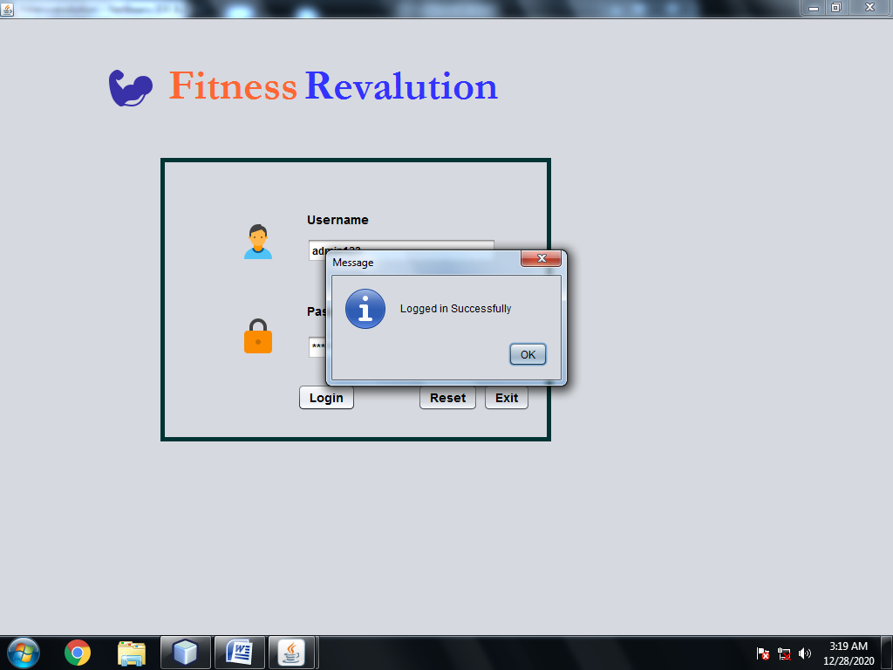

**Objeactive of Project** :

The main Objeactive of Project is to ease and manage work more effectively and efficiently.

Exclusive components includes admission , trainer’s data , packages as well as member record’s

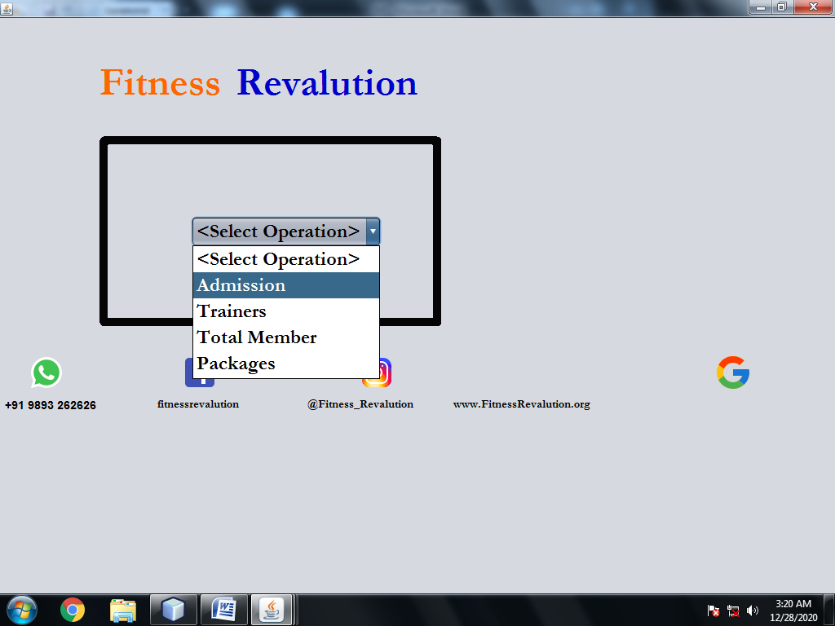

**Software & hardware requirements Specifications**.

Introduction : The following are the requirements to run this program on a system.

* Software requirements :Operating System :- Linux , Windows (Xp ,7,8,10), & Mac.

JVM must be install in the system and Jdk 8.0.2 or above..!

As well as Netbeans IDE 8.0 to run the code

* Hardware requirements: Intel dual core or Higher

RAM minimum 2GB to run the S/W.

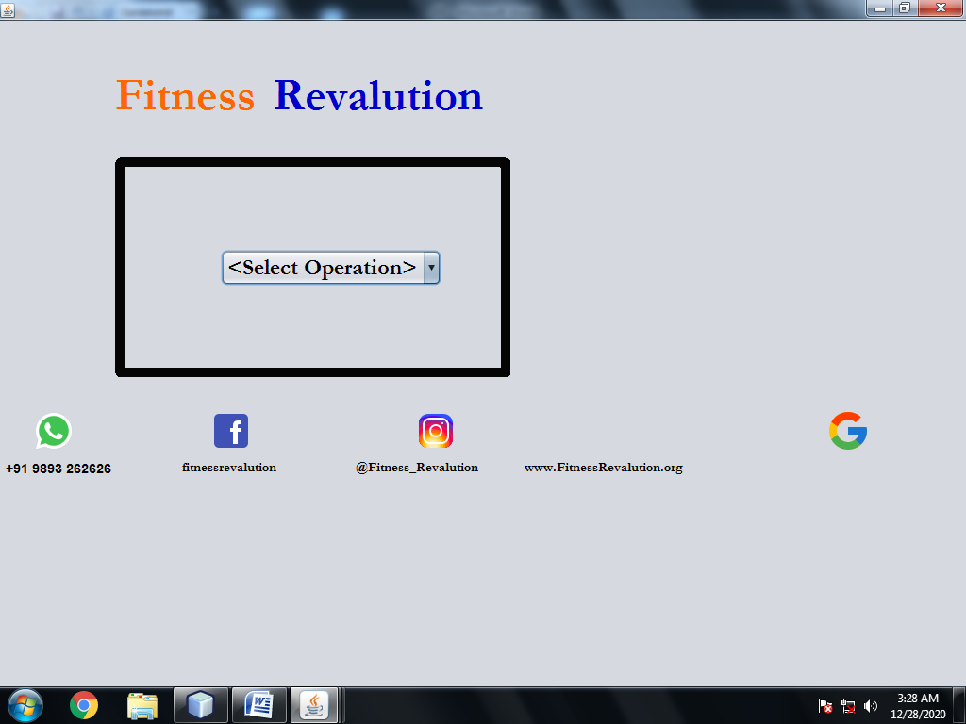

**System Design**

Introduction : The S/W is made using two different approaches to reach it’s results.

* Data flow diagram :- It approach Event-Driven Programming and Object oriented Programming both approach are implement the S/W.

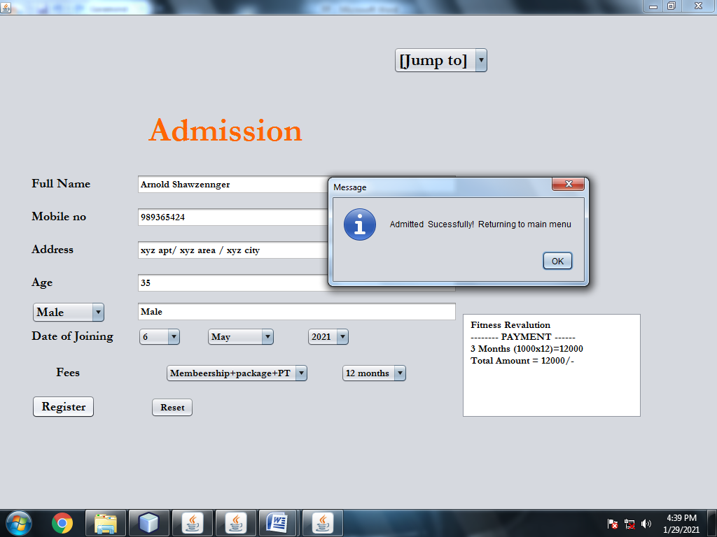

**Team member’s**:-

* Abdul Mannan Khan (Team Leader )
* Mohammed Fuzail Khan
* Moosa Khan
* Hitesh Mirchandani

**Bibliography**

* **Head First Java originally Published :2003**
* **Thinking in Java originally Published :1998**